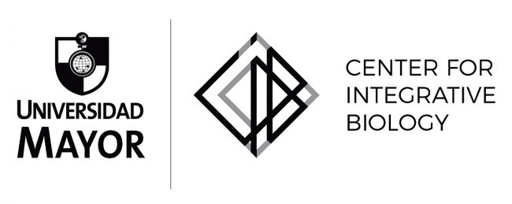

Post-Doctoral Position
Age-related Neurodegenerative Diseases.

Laboratory of Dr. Felipe Court, Center for Integrative Biology Universidad Mayor (Campus Huechuraba, Santiago, Chile).

We are seeking a highly motivated and creative individual to join our laboratory and the interdisciplinary group of the FONDAP Center for Geroscience, Brain Health and Metabolism in the Center for Integrative Biology, Universidad Mayor.

Topic and keywords: neurodegeneration, Parkinson disease, ageing.

Your Profile
- PhD (molecular, cellular), Immunology, Life Sciences or related disciplines
- Publication record with first-author research publication(s) in peer-reviewed journals
- Strong ability to work in a research team
- Prior experience in neuroimmunology, use of mouse models and neuronal cell culture is a plus

We offer
- A challenging job with contacts in national and international research environments l
- State of the art research facilities
- A competitive compensation package based on expertise and experience
- Financial support is available for at least 3 years. However, the successful candidate is encouraged to obtain a personal fellowship (National funding organizations).

Starting Date: January-March 2023 (other starting dates can be discussed)

To apply send the following information to courtlab@umayor.cl :
- Cover letter
- Detailed CV
- Contact details for three references

For more information, feel free to contact felipe.court@umayor.cl

Information about the Lab and the Center:

https://scholar.google.cl/citations?user=zTFS7UkAAAAJ&hl=en
https://cib.umayor.cl/
www.gerochile.cl

