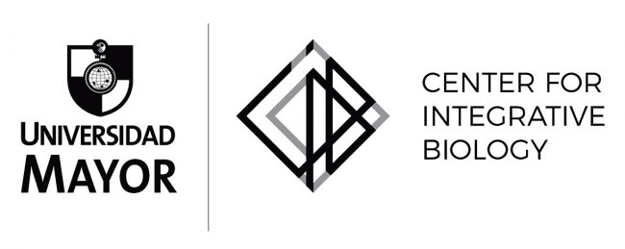

Research Assistant position

Aging Biology (Geroscience) and age-related Neurodegenerative Diseases.

Laboratory of Dr. Felipe Court, Center for Integrative Biology Universidad Mayor (Campus Huechuraba, Santiago, Chile).

We are seeking highly motivated and creative individual to join our laboratory and the interdisciplinary group of the FONDAP Center for Geroscience, Brain Health and Metabolism in the Center for Integrative Biology, Universidad Mayor, under a MJ Fox Foundation grant.

Topics: Mechanisms of neurodegeneration in age-related neurodegenerative conditions.

Your Profile
- Previous work in Neurobiology (molecular, cellular), Life Sciences, Neuroinmunology or related disciplines
- Strong ability to work in a research team
- Prior experience with mouse models and neuronal cell culture is a plus
- Publication record with first-author research publication(s) is a plus

We offer
- A challenging job with contacts in national and international research environments
- State of the art research facilities
- A competitive compensation package based on expertise and experience
- Financial support is available for at least 2 years.

Starting Date: January-March 2023

To apply send the following information to courtlab@umayor.cl :
- Cover letter
- Detailed CV
- Contact details for three references

For more information, feel free to contact felipe.court@umayor.cl

Information about the Lab:
www.courtlab.cl
https://cib.umayor.cl/
www.gerochile.cl

